Project Design Phase-II

Data Flow Diagram & User Stories

|  |  |
| --- | --- |
| Date | 03 October 2022 |
| Team ID | PNT2022TMID09697 |
| Project Name | Skill / Job Recommender Application |
| Maximum Marks | 4 Marks |

# Data Flow Diagrams:

A Data Flow Diagram (DFD) is a traditional visual representation of the information flows within a system. A neat and clear DFD can depict the right amount of the system requirement graphically. It shows how data enters and leaves the system, what changes the information, and where data is stored.

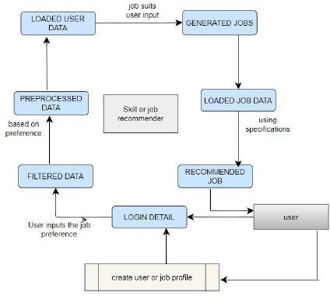

# User Stories

|  |  |  |  |  |  |  |
| --- | --- | --- | --- | --- | --- | --- |
| **User Type** | **Functional Requirement (Epic)** | **User Story Number** | **User Story / Task** | **Acceptance criteria** | **Priority** | **Release** |
| Customer (Mobile user) | Registration | USN-1 | As a user, I can register for the application by  entering my email, password, and confirming my password. | I can access my account / dashboard | High | Sprint-1 |
|  |  | USN-2 | As a user, I will receive confirmation email once I have registered for the application | I can receive confirmation email & click confirm | High | Sprint-1 |
|  |  | USN-3 | As a user, I can register for the application through Facebook | I can register & access the dashboard with Facebook Login | Low | Sprint-2 |
|  |  | USN-4 | As a user, I can register for the application through Gmail |  | Medium | Sprint-1 |
|  | Login | USN-5 | As a user, I can log into the application by entering email & password |  | High | Sprint-1 |
|  | Dashboard | USN-6 | As a user, I can access the dashboard for jobs to search | I can access the dashboard | High | Sprint-1 |
| Job seeker (Web user) |  | USN-7 | a user, I can log into the application by entering email & password | I can log into the account I have created | High | Sprint-1 |
| Administrator |  | USN-8 | As a administrator, I can see the registration details | I can access the registration  details | High | Sprint-1 |
|  |  | USN-9 | As a administrator, I can see the login details | I can access the login details | High | Sprint-1 |
|  |  | USN-10 | As a administrator, I can update the dashboard | I can update the dashboard | High | Sprint-1 |